**DAILY ONLINE ACTIVITIES SUMMARY**

|  |  |  |  |
| --- | --- | --- | --- |
| **Date:** | 4/06/2020 | **Name:** | Krishnitha |
| **Sem & Sec** | 4th sem, A Section | **USN:** | 4AL18CS039 |
| **Online Test Summary** | | | |
| **Subject** | Microcontroller and Embedded System | | |
| **Max. Marks** | 20 | **Score** | 13 |
| **Certification Course Summary** | | | |
| **Course** | 1) Python for Machine Learning  2) Trailhead Basics | | |
| **Certificate Provider** | 1) Great Learning  2) Sales Force | **Duration:** | 1) 1 hr  2) 3 hrs |
| **Coding Challenges** | | | |
| **Problem Statement:**  1) write a java program to read three integer values from the keyboard and find the sum of the values. Declare a variable “sum” of type int and store the result in it.  2) Write a C++ program to find the missing number in array. | | | |
| **Status:** Executed | | | |
| **Uploaded the report in GitHub** | | YES | |
| **If yes Repository name** | | <https://github.com/krishnitha/Java-coding>  <https://github.com/krishnitha/C-coding> | |
| **Uploaded the report in slack** | | YES | |

**Online Test Details:**

Today we had assessment in the subject Microcontroller and Embedded Systems. The test was based on third module of this subject. There were total 20 number of questions of ONE mark each, out of which I scored 13.

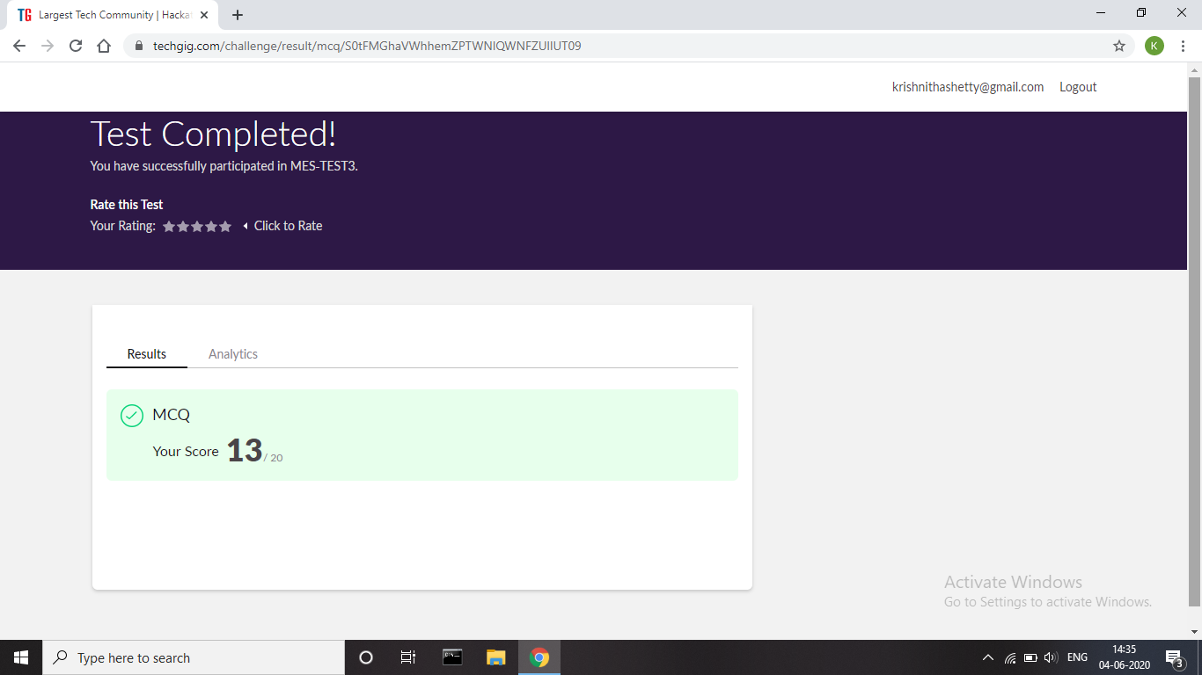

**Certification Course Details:**

Today I have done course of python for machine learning. I have completed all the modules of this course. Today I learnt about Lambda functions and its uses and also learnt about Classes and Objects.

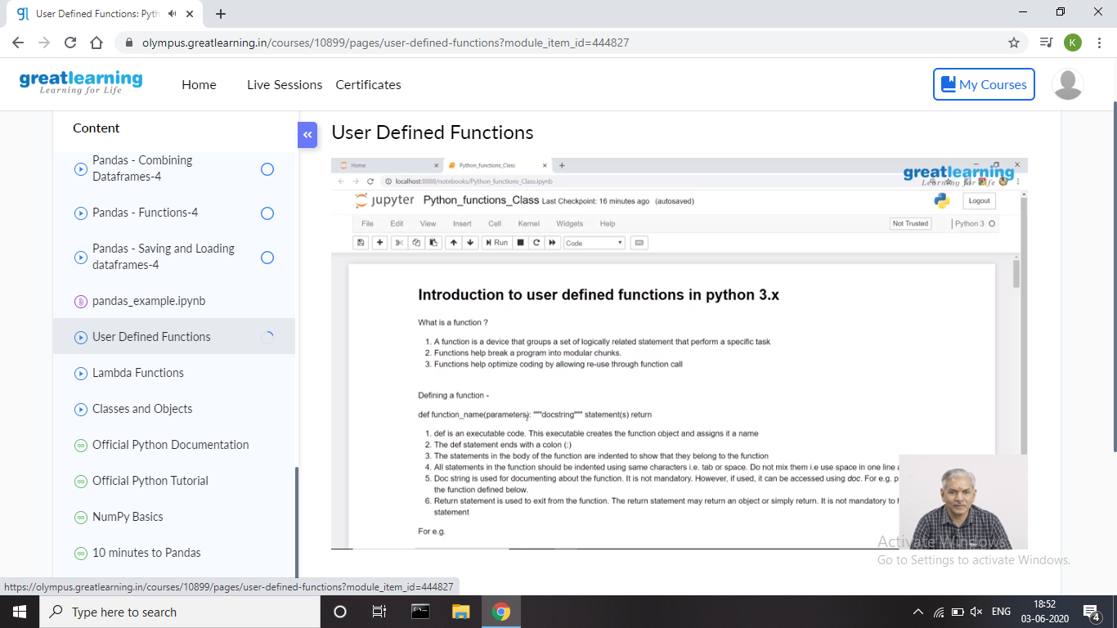

Also, I have done certification course on Trailhead Basics. I learnt about the Picklist administration2. I also learnt how to share values with global value sets and to manage my picklist values.

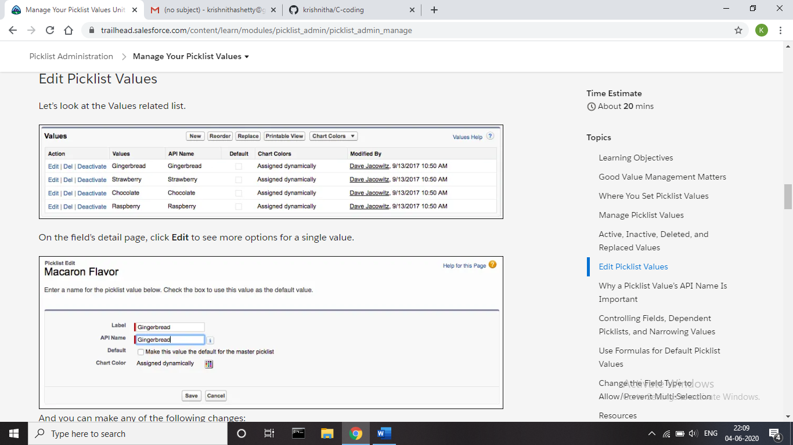

**Coding Challenges Details:**

**Problem 1:** write a java program to read three integer values from the keyboard and find the sum of the values. Declare a variable “sum” of type int and store the result in it.

**Solution:** Uploaded it in GitHub

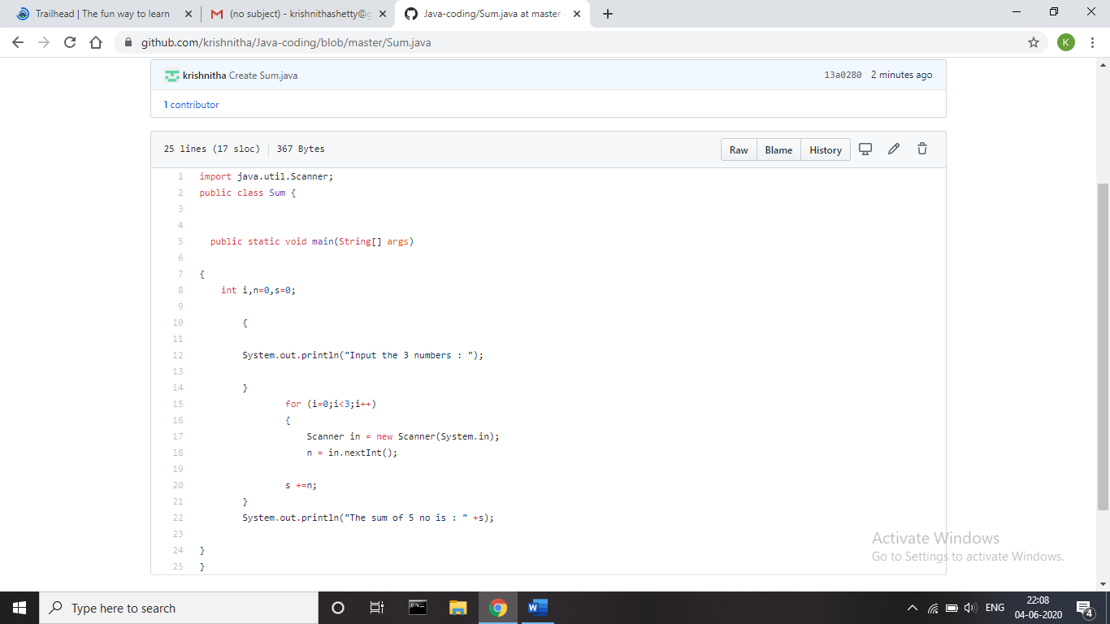

**Problem 2:** Write a C++ program to find the missing number in array.

Given an array C of size N-1 and given that there are numbers from 1 to N with one element missing, the missing number is to be found.

**Input:**  
The first line of input contains an integer T denoting the number of test cases. For each test case first line contains N(size of array). The subsequent line contains N-1 array elements.

**Output:**  
Print the missing number in array.

**Constraints:**  
1 ≤ T ≤ 200  
1 ≤ N ≤ 107  
1 ≤ C[i] ≤ 107

Example:  
Input:  
1  
5  
1 2 3 5

Output:  
4

**Solution:** Uploaded it in GitHub

